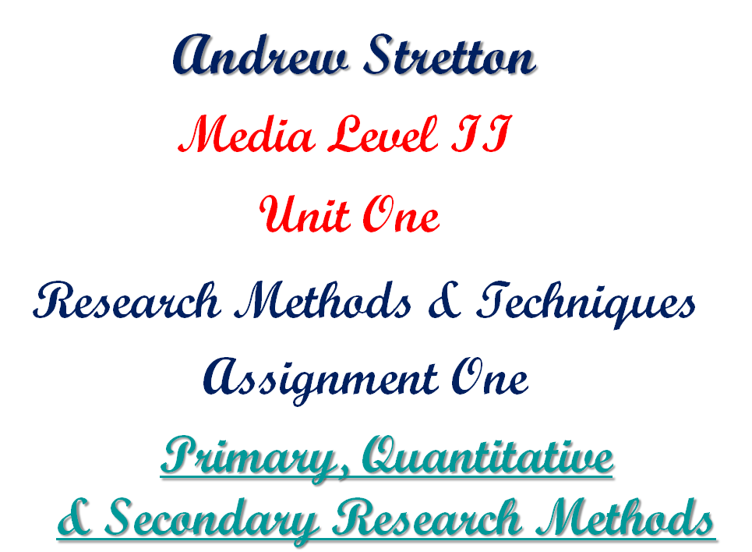

OUTLINE

Primary Research is the starting point of a write, task(s) or area(s) that are to be explored that enable the hands-on work to be carried out successfully. I am going to use the three methods: Primary, Quantitative and Secondary based upon some of my achievements and include what researchers do themselves at certain stages.

Within my Primary Research I have decided to add some diagrammatic ideas, which is a form of Graphic Design, along with Photographs of Art to coincide with the text and to add interest to my writings as after all I feel that my idea will coincide with this Media Course I have embarked upon. I have decided to include with Primary and Quantitative Research my Flat that I transformed when I was thirty-two years old.

For my Secondary Research, I have decided to display some of my Art work, that is pencil drawn along with some photographs and my Graphic Design work that was all carried out using PowerPoint’s drawing tools.

I am going to combine the Primary, Quantitative♣ and Secondary methods within this Word document, giving it a fancy look, i.e. overlaps of Photographs, because I want to give my work a DTP display, but without any column work and it will also be displayed using landscape and portrait page layouts with footnotes which will add an advanced Word Processing feature and also I will be including initial capitals when and where I feel necessary for my way of writing this essay.

Finally, I will also include an animated PowerPoint presentation which will show another way of displaying my research.
INTERIOR DESIGN PROJECT

BATHROOM

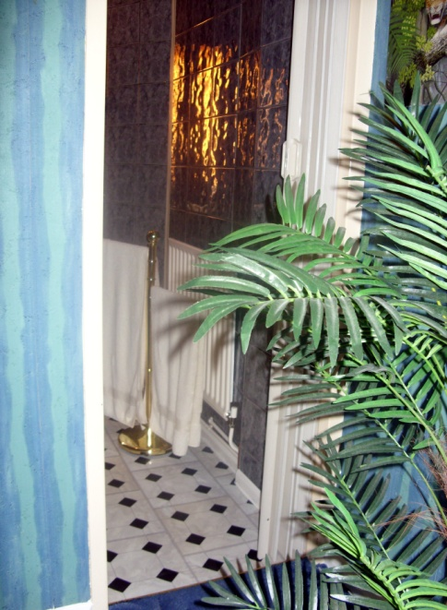
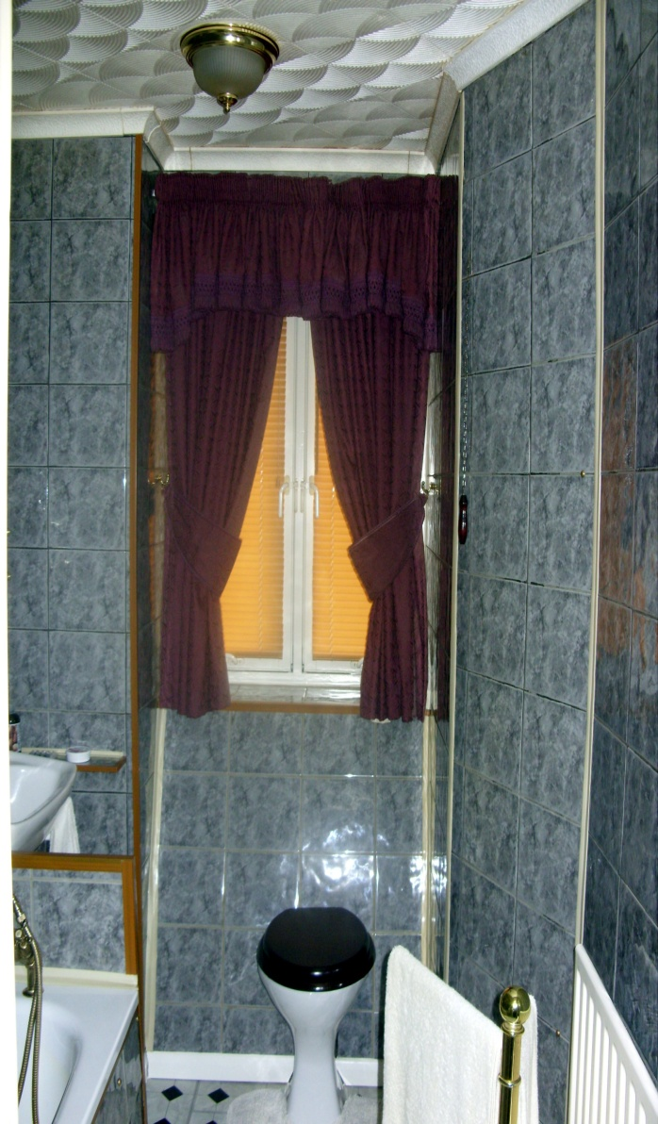
I carried out this task which was a complete transformation job, where I envisaged a Luxurious Flat, especially within entrances, where first impressions are lasting impressions.

Within the bathroom area I wanted to create a warming feel and look and therefore envisaged a relaxed tonal effect, i.e. darker walls with a lighter floor that would match the bath, sink and toilet.

On completion, I would also apply a lighting dimmer system for a very stylish and comfortable evening bath.

This diagram is where I covered the toilet system and any other seen pipes to take away the original look and apply a bit of style.

Of course, there are maintenance issues to consider which is why I made sure that all coverings would be detachable.

BATH AND SINK AREAS

The opposite diagram shows additions. Originally the side boarding
of the bath was just thin hardboard which would not hold the heavy
thick tiles I had to hand and therefore I used the toilet covering
materials which was ¼ inch plywood.

The back tiled area is an addition that would bring out the brass taps
and also join it together with the sink as shown in the latter
photograph.
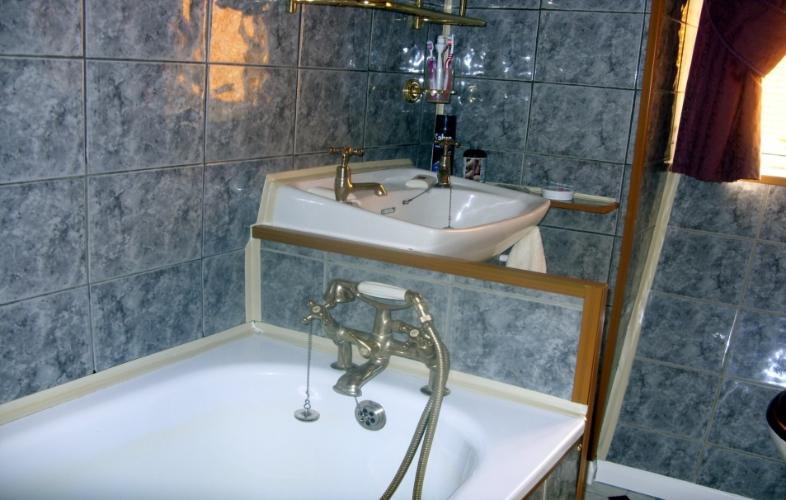

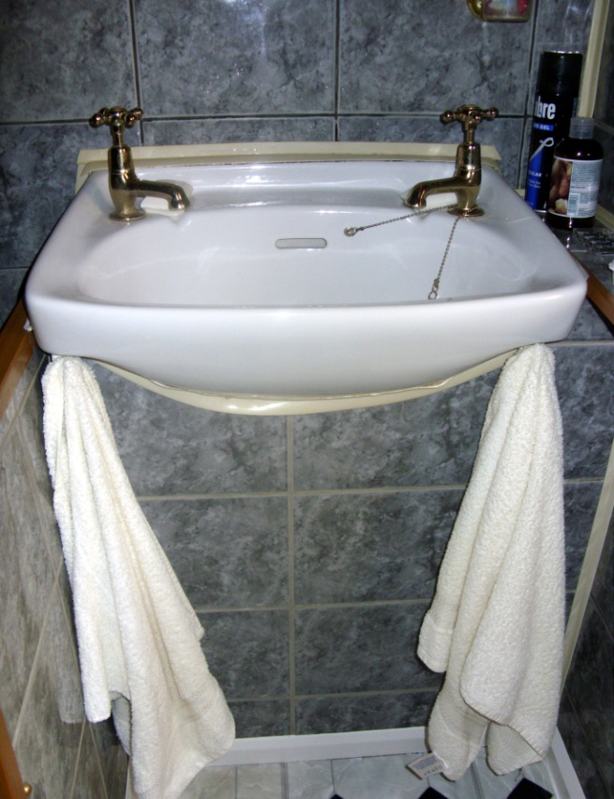
This is a diagram of the under-sink area. I first had to pencil shape for the cut-out area. I then stuck the tiles and when fully dried, I cut out the shape with a tile saw.

KITCHEN
For this area I wanted to create a brighter look and feel and therefore used lighter marble tiles and all cupboard doors would be replaced with manufacturer’s made marble coated material. I also wanted the early seventies look which was Louvre doors (not illustrated.) This would give two combinations and with my design on the floor would give a stylish finish.

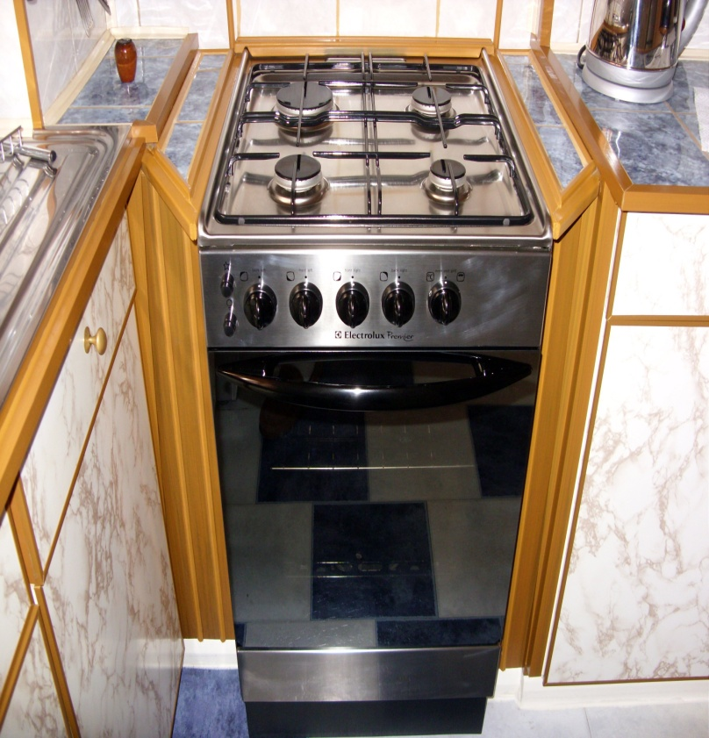
For the cooker area design the cooker slides out with a Louvre door to the side enabling access to any pipes that are connected to the taps and other pipes that may need to be got to if any future problems.

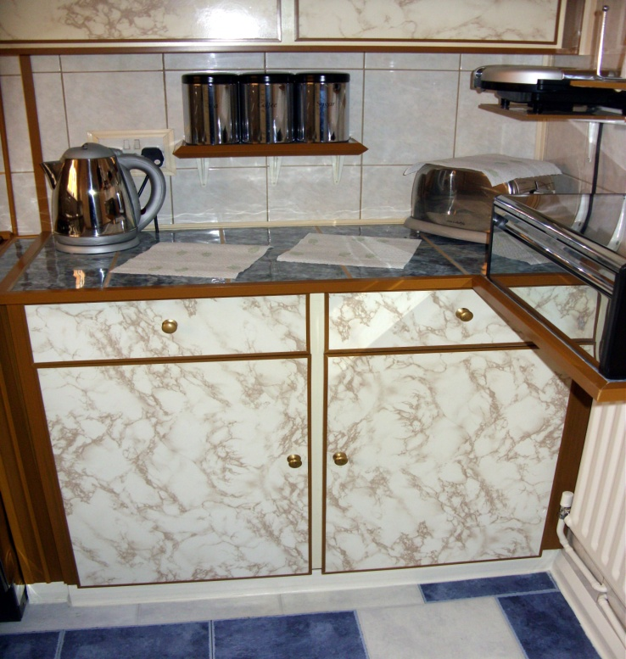

For the tea, coffee and light food preparation area and all other surface areas, I went for blue marble tiled tops that would bring out the marble coated cupboard doors.

KITCHEN ADDITIONS
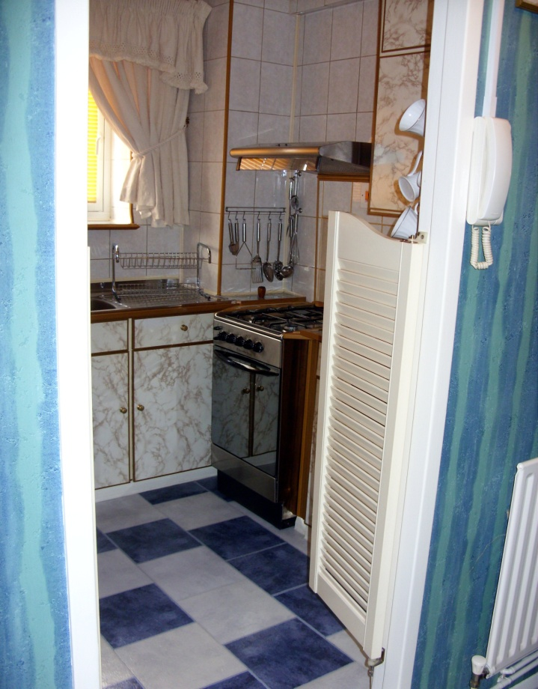
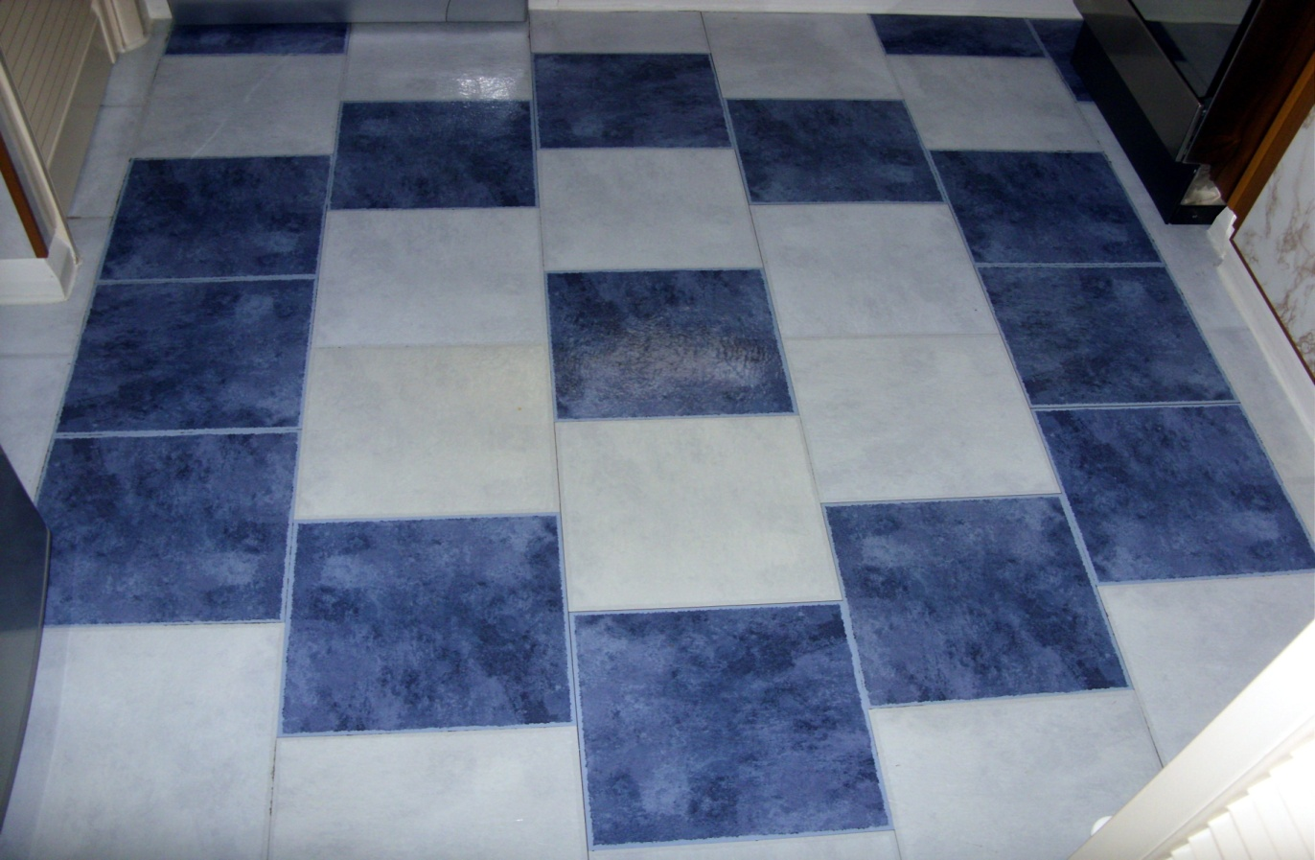
BEDROOM
I have included two other photographs of the kitchen entrance area. The second display, I feel, is a welcoming look and the first shows my floor design, which I did fully from mind using no pencil and it goes well with the blue marble working tops.

The area next to the cooker hood is also covered to hide pipes.

More wooding is also included around the whole top side of the window.

The kitchen was the most pipe area seen needing a lot of attention.

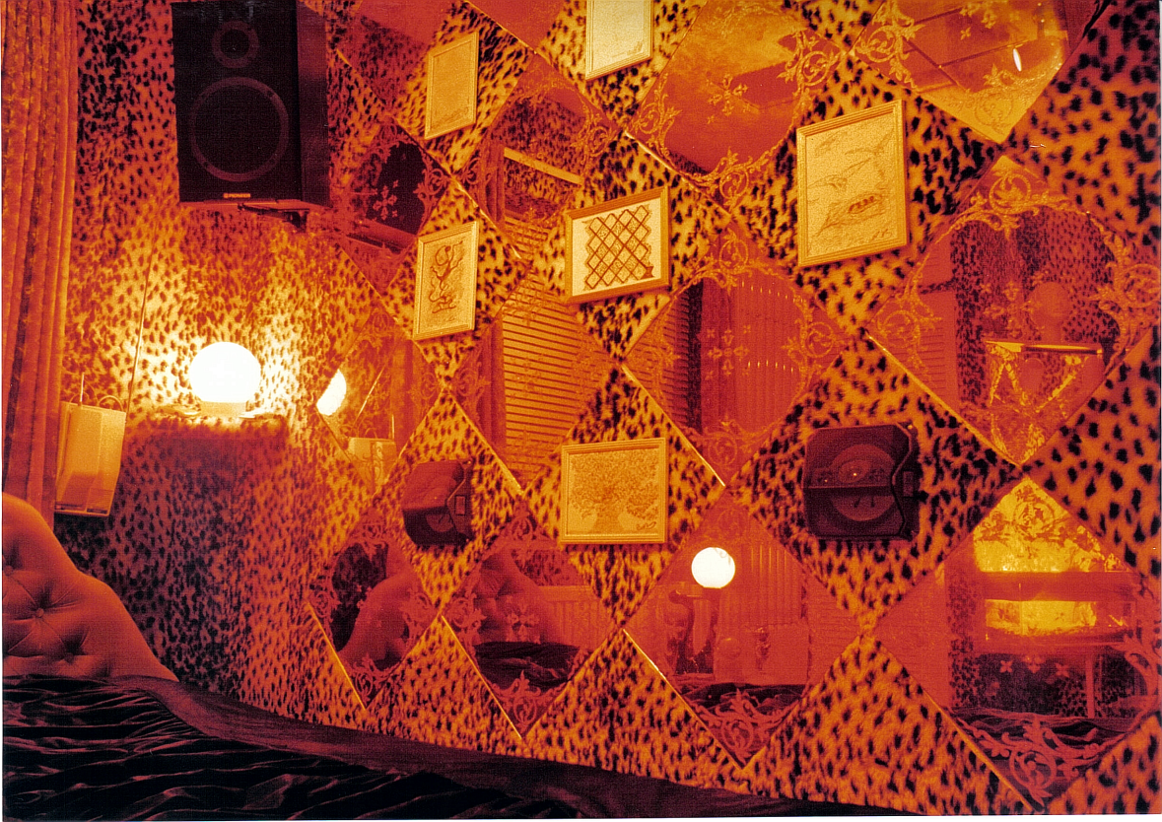
The design below is what went with the photograph opposite. This was my bedroom mirror design at the age of twenty when I designed and decorated my whole bedroom. The opposite photograph also shows some drawings I did later on.

It was later that I decided to use this design for my flat, which is illustrated below, but I did not want fancy patterned stained mirrors just clear ones.

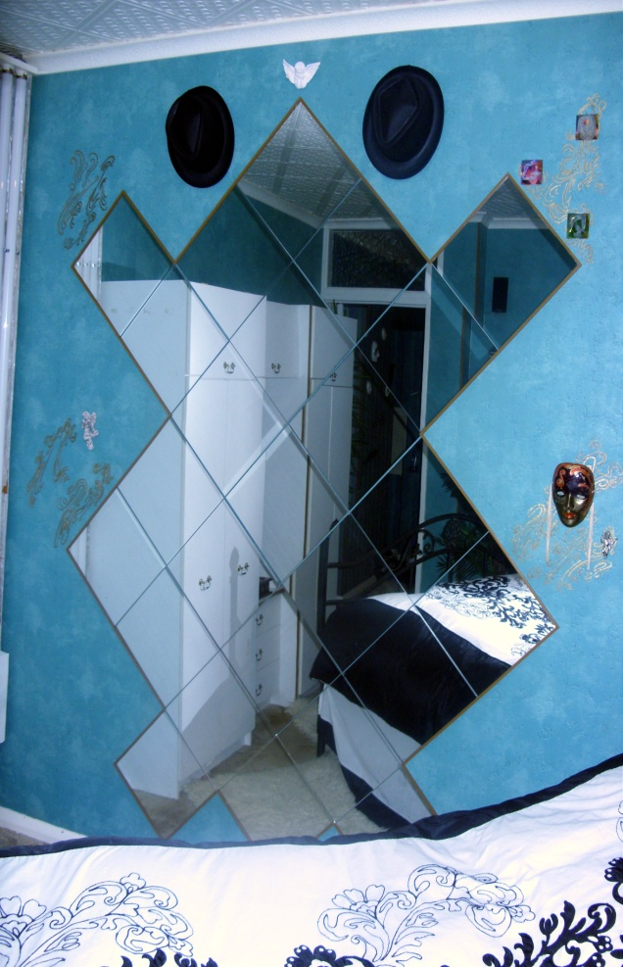
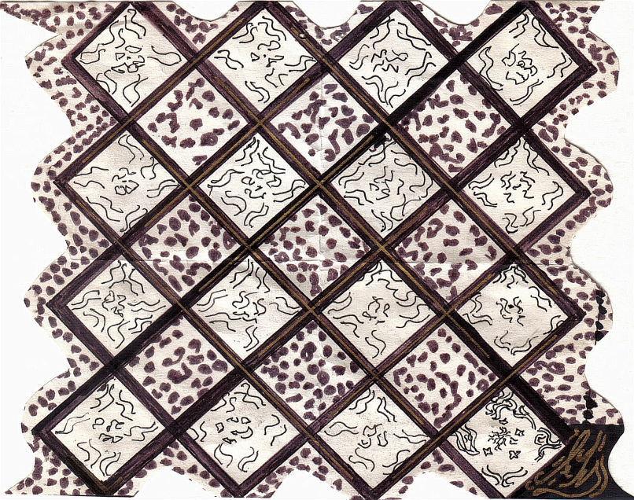

PHOTOGRAPHIC DISPLAY
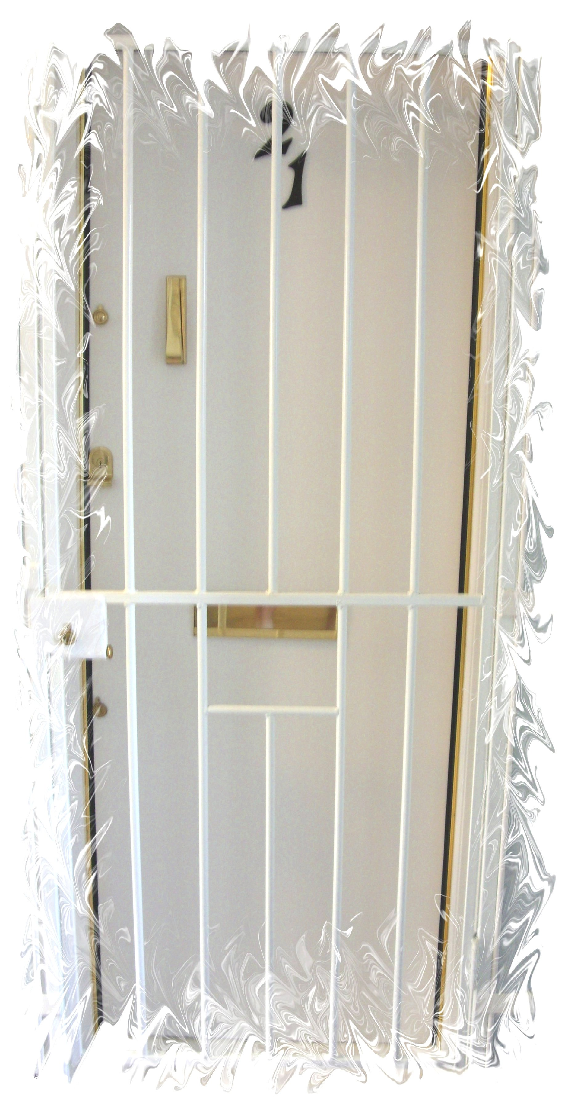
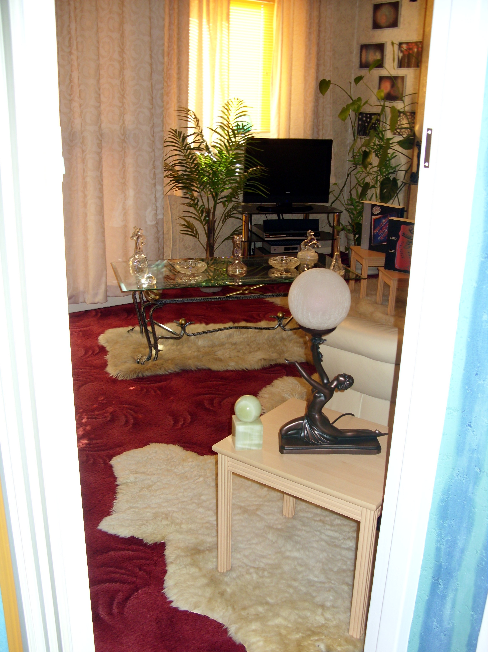
I have included three other photographs which are entrances again and caught on my digital camera the Samsung S10655 X Optical Zoom.

For the editing I used the Samsung’s software and the effect around my front door is known as the Artistic effect.
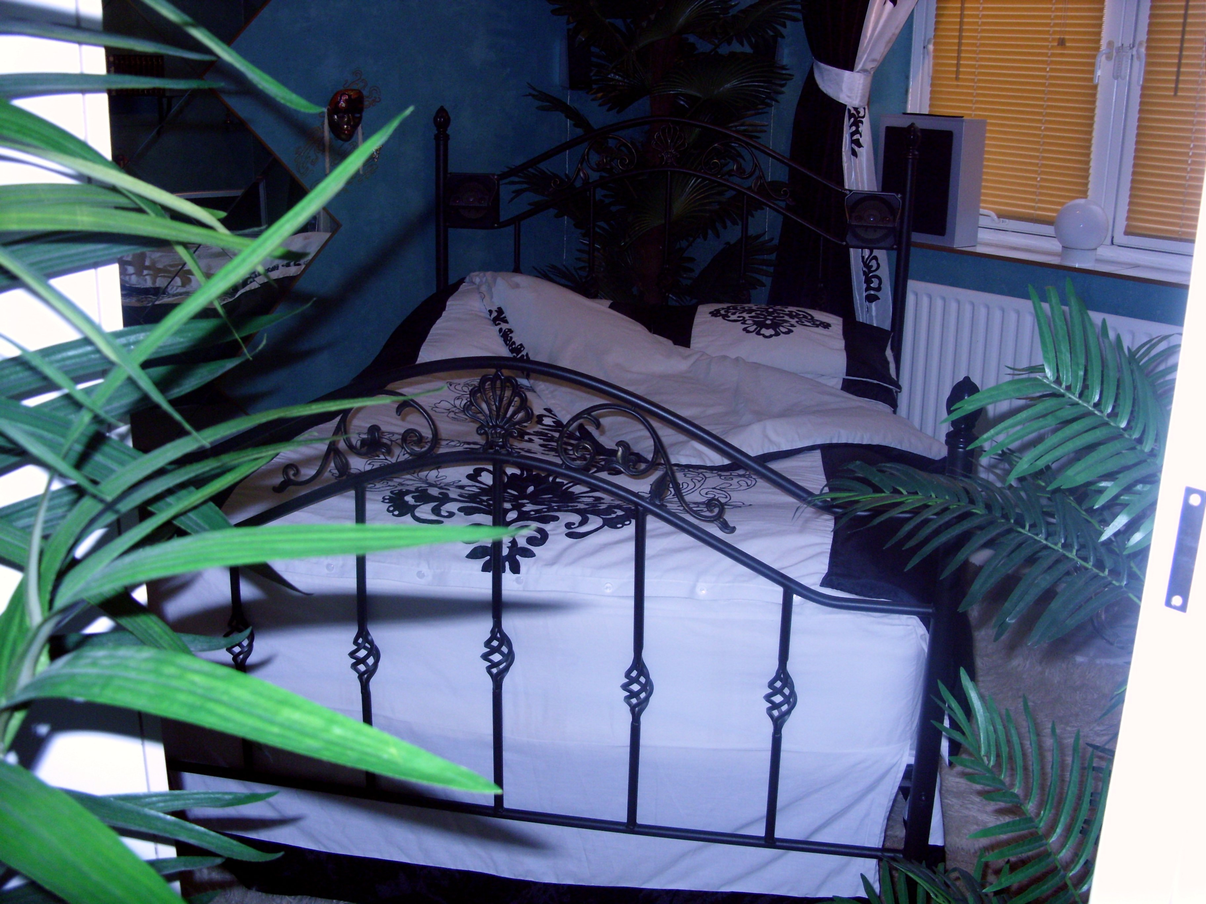
QUANTITATIVE RESEARCH

Within this area I am displaying my initial costs within a year’s period of the restoration and living conditions that I expected from these figures.

SECONDARY RESEARCH
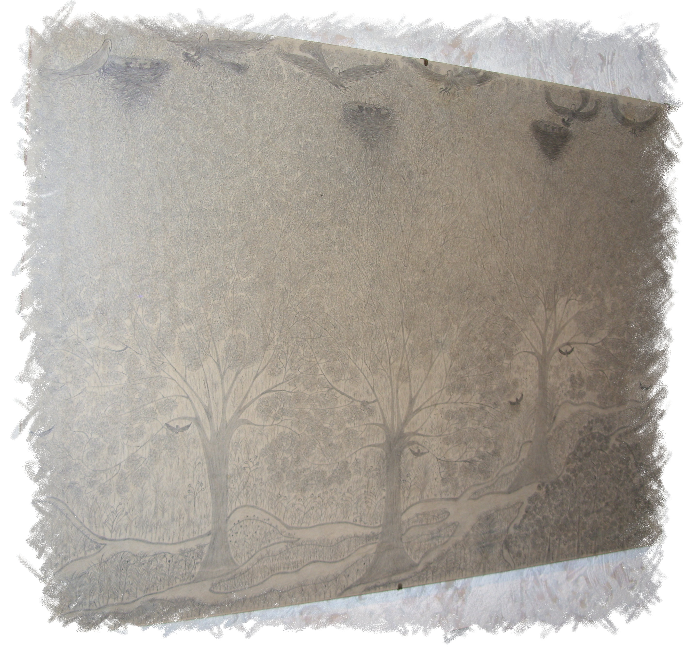
Within my Secondary♣ Research the drawing opposite is one that I drew from imagination when I was thirty years old and it measures three feet by two feet.
I spent about a month on it and this type of drawing is my favourite style. I like trees, forestry and birds of prey and I also tend to go for pattern style work.


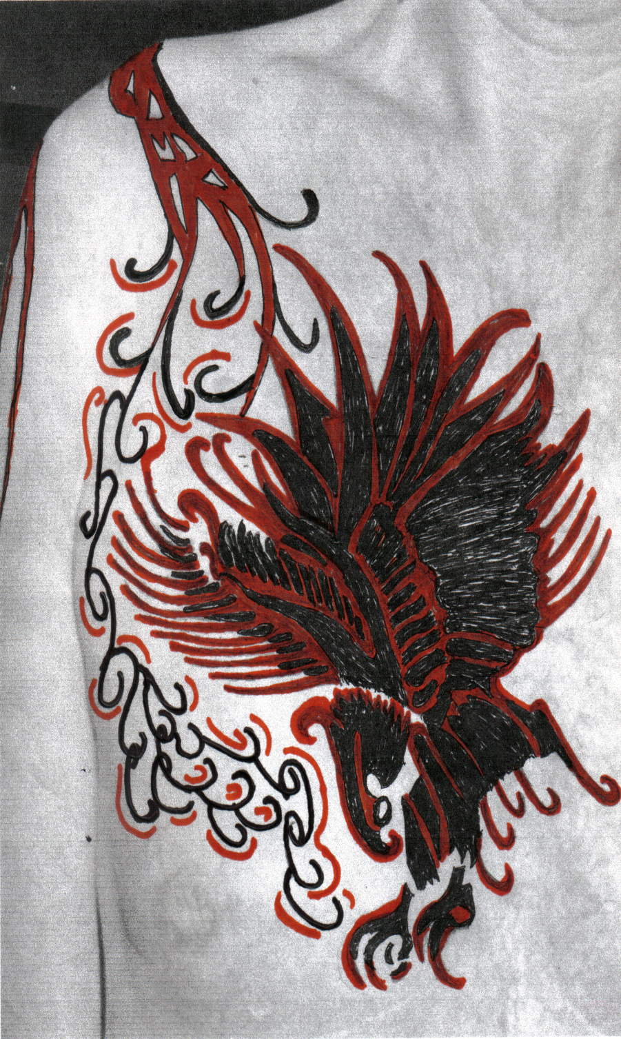
My Opposite tattoo is
another drawing
from imagination
when I was Twenty-Two years old.

I drew it on A4 paper and spent About two weeks on it.

The design next to it
is a PowerPoint
drawing to go with
the pattern works
which also runs
down my right arm.

GRAPHIC DESIGN
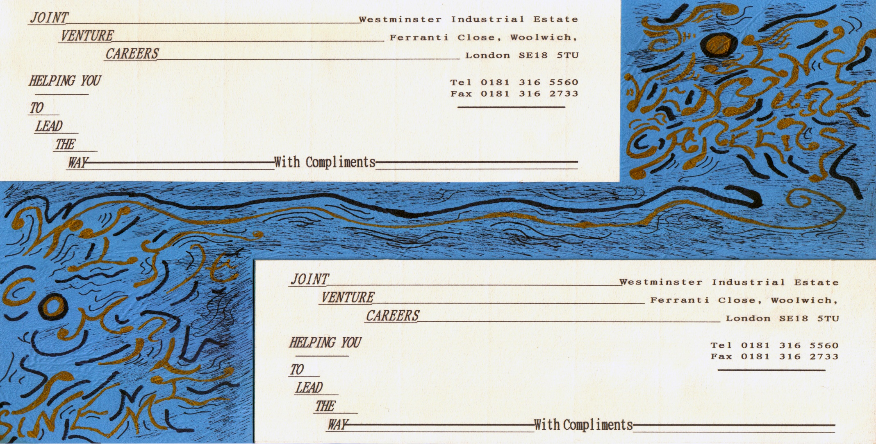
The page before is the very first complimentary slip I designed, but using WordPerfect 5.1 for DOS (Disk Operating System) when I was twenty eight years old.
The next page is the business card that went with it.
I did these designs on a Level II Administration Course where a Recruitment Agency had to be set up.

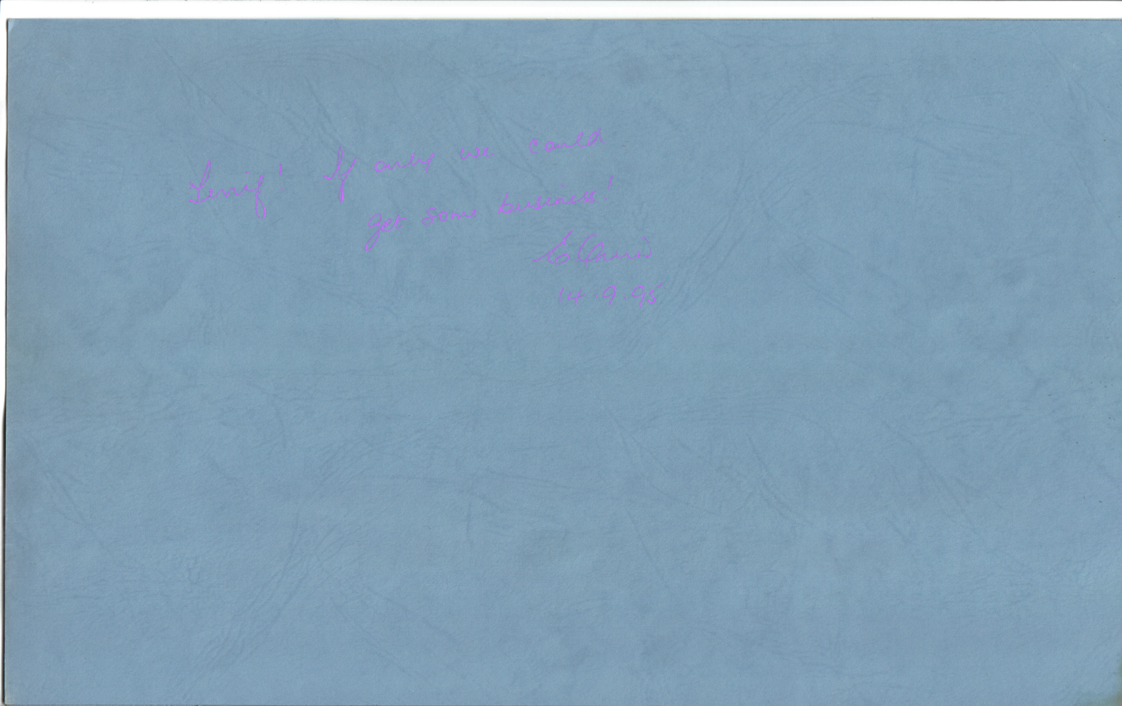
The page before is the very first complimentary slip I designed but using WordPerfect 5.1 for DOS (Disk Operating System) when I was twenty-eight years old.
The next page is the business card that went with it.
I did these designs on a Level II Administration Course where a Recruitment Agency had to be set up.

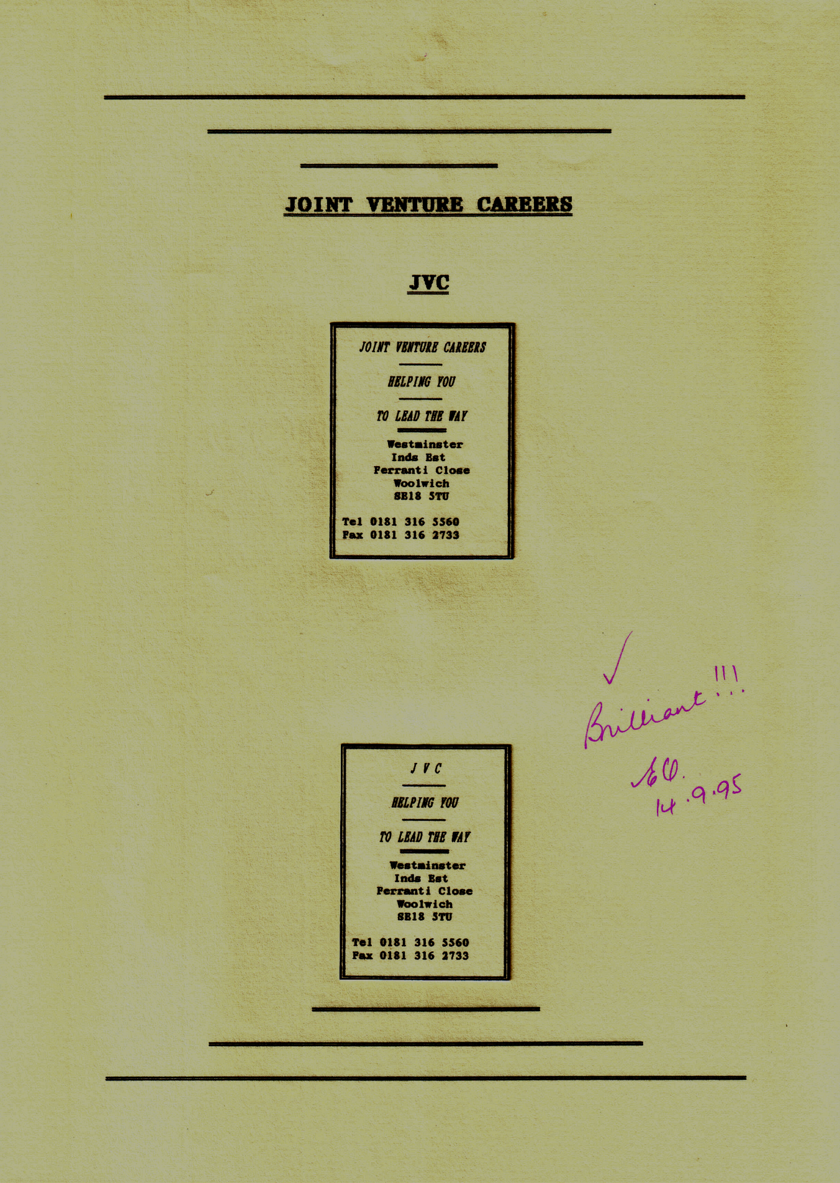

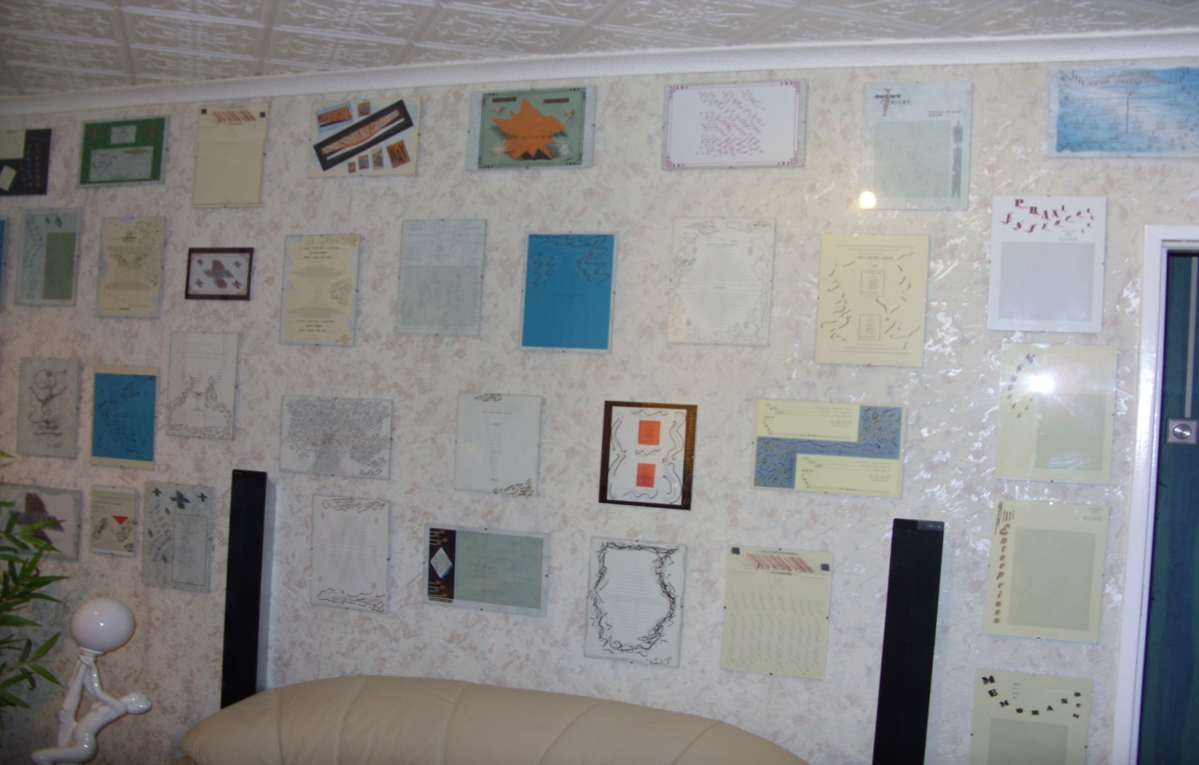
I have included a photograph of my PowerPoint Gallery. I first started to design this when I was twenty-nine years old. This side is a mixture of all sorts including some pencil drawings.
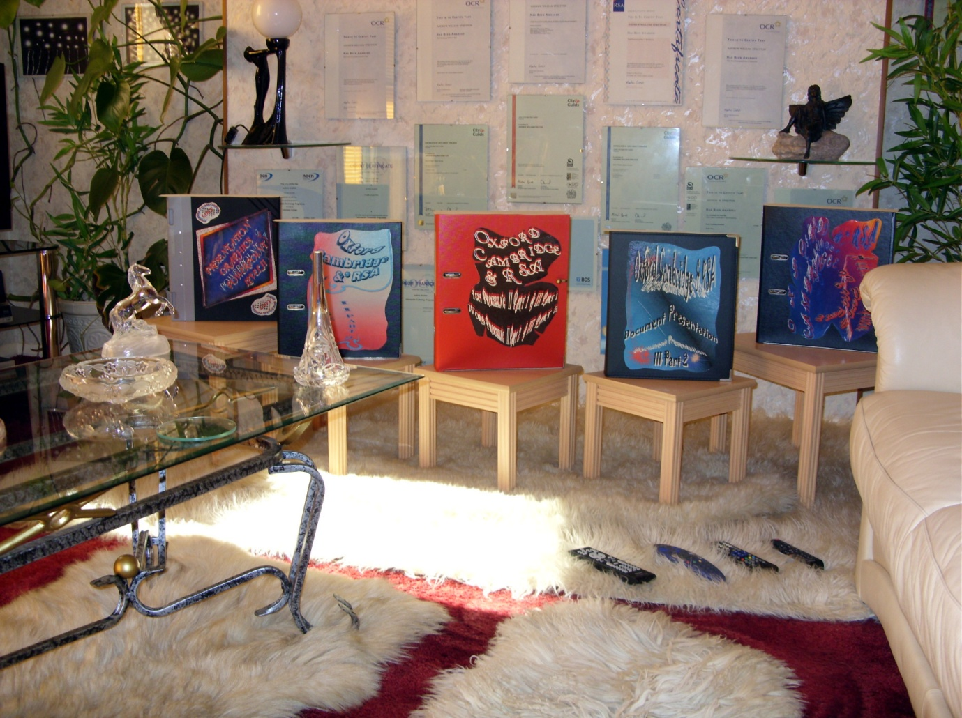
This display of Portfolios is my OCR Typing Examinations that I did when I was thirty years old.
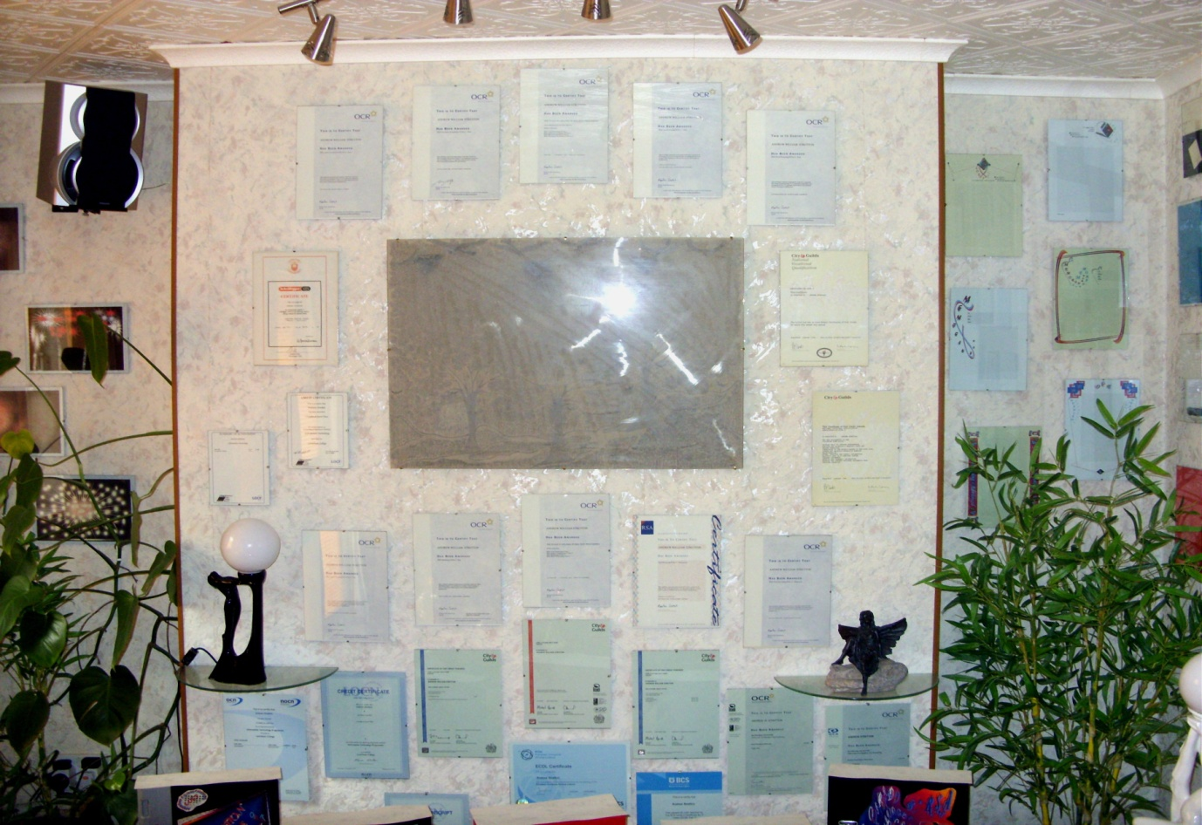
I have included my wall of qualifications that start from twenty-eight years old, totalling thirty five units of Level Two and Three for Administration, Secretarial and Using IT, but the idea of this display is a Graphic Design method of Collage as with my whole gallery as well.
HYPERLINK MOUSE OVER TECHNIQUE

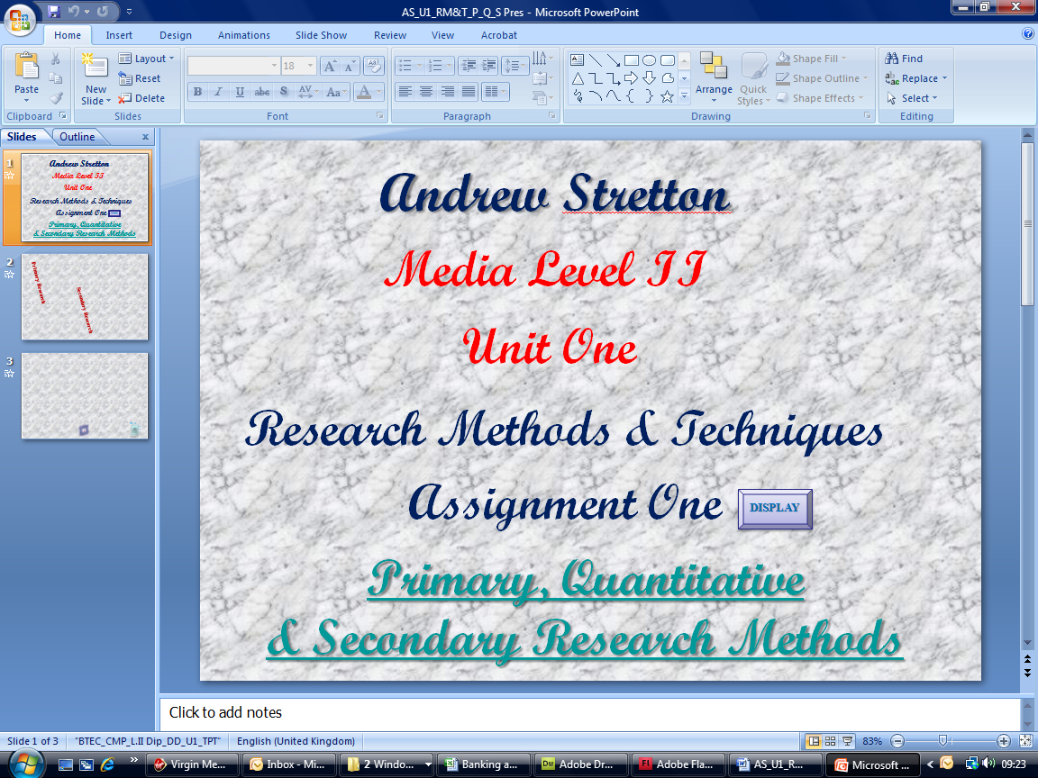
Below is a screen print of the PowerPoint display that contains all my research using the mouse over hyperlink technique.
- Click “Shapes.”
- Click the symbol you’d like from the “Action Buttons” section and drag the “Crosshair” holding down and releasing the left handle of the mouse and the “Action Settings” dialog box will appear.
- Within the “Action on Click” section click the “Down Arrow” and scroll down and click “Slide.”
- Now click the slide you want to go to within the “Hyperlink to Slide” dialog box.
- Click “OK.”
- Now click the “Mouse Over” tab.
- Within the “Action on Mouse Over” section click the “Hyperlink to” “Radio Button.”
- Click the “Down Arrow” again, scroll down and click “Slide” again.
- Now click the same slide again within the “Hyperlink to Slide” dialog box.
- Click “OK.”
- Click “OK” again.
- Repeat this procedure throughout all slides and for their returns.

ADDING SOUND

This procedure may also be carried out within the “Action on Click” dialog box as with the previous procedure.
POWERPOINT DISPLAY
- Click “Link” with the left handle of the mouse.
- Right click the right handle of the mouse.
- Click “Edit Hyperlink.”
- Within the “Action on Click” section click the “Check Box” for the “Play Sound” function.
- Click the “Down Arrow” and scroll down to select Windows pre-installed sound files or it is also possible to stop previous sounds and add your own using the “Other Sound” option.

♣ Statistical chart of my restorational costs. This area of research enables a researcher(s) to display their findings and up-date the figures as and when and if it should become necessary.
♣ This area of research also enables a researcher(s) to display their findings using Photographs, Pictures and any other Media form that is useful for display.

